**Self Project -**

Github link - [https://github.com/Gourav-s12/RoutineMaker](https://github.com/Gourav-s12/Virtual-Mouse-Paint)  
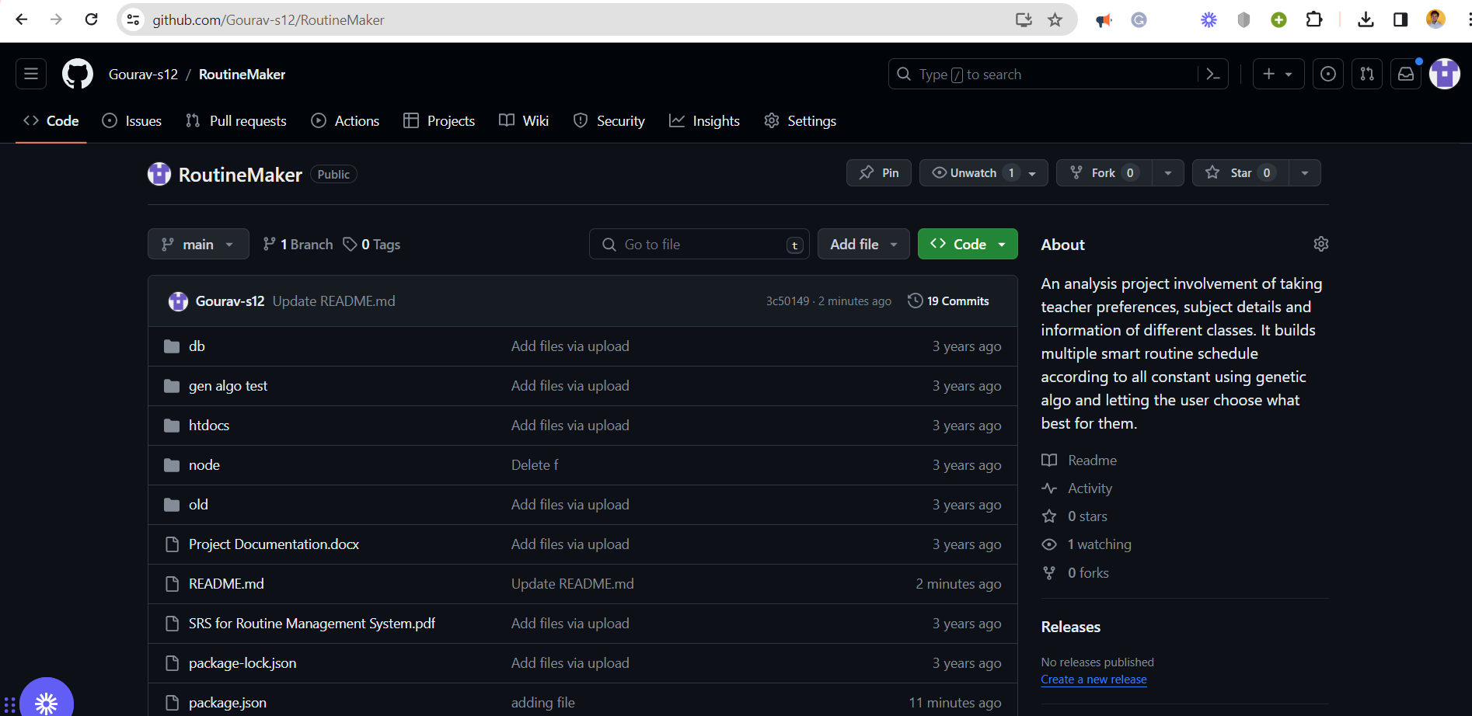

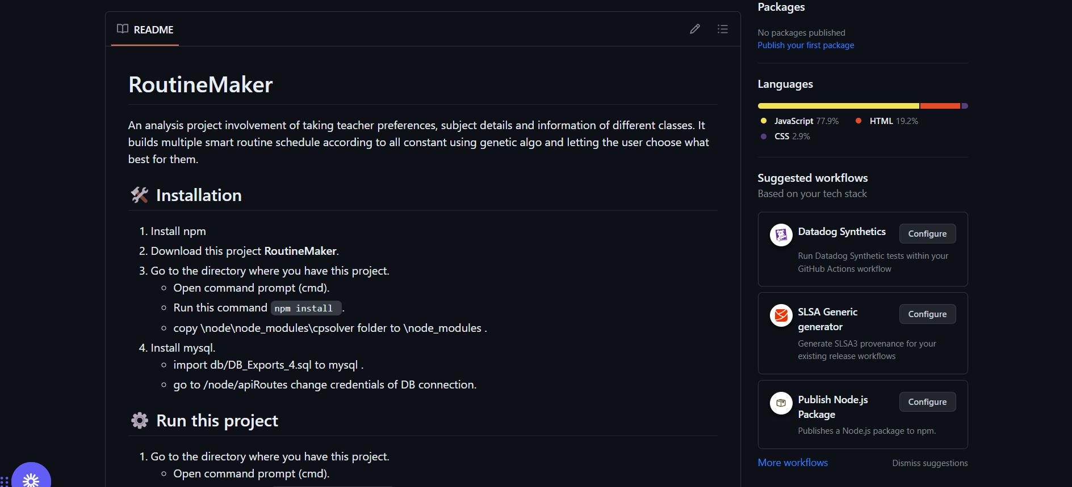

This project is develop by me (self project) .